REACT COURSE NOTES (13-09-24)

React is an abstraction which allows developers to not have to interact with the DOM directly in an Imperative way (ie no calls to addEventListener() or querySelector() etc) and so the UI can be thought of as a reflection of the current data (properties and state)

Our first example of a react app

This is to show the basics of using State and Props along with asyncronous call to an api. It shows a 'tip' eg Never eat snow that isn't white and then a count of how many times the button has been clicked to show a new tip.

//when using react functionality use this import statement to load the relevant components
import { useEffect, useState } from "react";

//This is the main react component which is always called App by default, it is an
//export(ed) function so it can be imported within the index.js file (the actual web page)
export default function App() {
const [advice, setAdvice] = useState("Click to get advice");
const [clickCount, setClickCount] = useState(0);

//we use an async function as we are communicating with the advice api where we will wish
//to await it's response.
async function getAdvice() {
setClickCount((c) => c + 1);
const res = await fetch("https://api.adviceslip.com/advice");
const data = await res.json();
setAdvice(data.slip.advice);
}

/*useEffect(function () {
getAdvice();
}, []);*/

return (
<div>
<h1>{advice}</h1>
<button onClick={getAdvice}>Get Advice</button>
<Message clickCount={clickCount} />
</div>
);
}

//New Component - Name with an uppercase letter, a bit like a class
//React should be broken down into seperate components wherever possible
function Message(props) {
return (
<p>
Number of clicks is: <strong>{props.clickCount}</strong>
</p>
);
//Notice return statements are followed by a semi-colon!!
}

Setting up a react app with create-react-app

Open up a terminal/command prompt
use dir rather than ls to list contents of the folder you are within when using Windows
Then use cd to navigate to the folder in which you want to build the app

During this course we will use version 5 of create-react-app and so we add the @5 to the create statement below -

Once you are in the correct folder write (ps the > is just to signify the terminal prompt DO NOT WRITE IT IN THE STATEMENTS
also [] are to denote a placeholder with description) -
> npx create-react-app@5 [name of your project eg pizza-menu]

This statement uses an NPM-Build tool which is a bit like a MAKE script apparently

We now have an index.html page which contains
<noscript>You need to enable JavaScript to run this app.</noscript>
<div id="root"></div>

in it's body element. This div .root is where the react app will be built because we have an index.js file which contains
import React from 'react';
import ReactDOM from 'react-dom/client';
import App from './App';//This is where we will write our react code inside a file called App.js we create the exported App() component (see below)
//Now we create the root of the app within the div with id "root"
const root = ReactDOM.createRoot(document.getElementById('root'));
//And finally we call the render method which is where the JSX is written to
root.render(
<React.StrictMode>
//Here we are creating the JSX component called App itself
<App />
</React.StrictMode>
);

Finally the boilerplate code within the App.js file
function App() {
return (
<h1>This is the JSX which will fill the <App /> element above</h1>
);
}

export default App;

Note: you can also write it as export default function App()

PS = react does not care about folder structure, it is just like it is because the developers of create-react-app decided it was good for the job and nice and tidy

Getting this app to run
If you look inside the file packages.json you will see that there is an object called "scripts" within which there are a few options including start (along with build, test, eject) and these can be run from the terminal within vscode (which is always within the directory you are working on) with the statement
> npm run [script name]

So when we run the start script it opens this project in a new browser tab which is running on the localhost at port 3000 which provides us with "Hot Module Replacement" (if it breaks simply manually refresh)

If you want to stop it running at any point press [cntl]+[c] within the terminal

Building our first react app "pizza-menu"

The "webpack" which built our new react project expects the entry point to be index.js

First thing to do is to use the imort JS statement to get our react stuff in there and available to utilise (see pizza-menu project which I will be working within directly rather than notes in here)....

Components are the building blocks of react – they have data, logic, and appearance and can be built and combined to create more complex components (nesting components for additional reusability). The first step for a design is to break down the app into a "component tree" which show Parent and Child relationships

Creating and reusing a component – We create components as functions with a Capital letter at the start of their names (a bit like defining a class in a c# etc) that must return a block of JSX

What is JSX? - It is a declaritive ("describe the UI based on current data ie Props and State") mark-up language like extension of JavaScript that allows you to write not only HTML but also CSS and JavaScript (including obviously React components which become a mark-up element of their own eg <Pizza /> from the function Pizza() compnent definition)
Browsers do not natively understand JSX and so a tool called Babel (as in the fish I guess) converts each element with React.createElement() method calls; therefore we could write all of the elements natively with React but JSX provides a shorthand form which is easier to read.

PROPS – The communication method between child and parent Components – We can send data down the component tree by adding the key/value pairs to the props object in the parent component and inspecting them in the child component (which is essentially a component constructor function) eg

function Menu() {
return (
<main className="menu">
<h2>Our Menu</h2>
{/*Now we can place an instance of our Pizza Component in here (ps this is a JSX comment
We're creating key/value pairs that are added to the props argument in their 'constructor'*/}
<Pizza name="Vegan Glory" price={12} />
{/** We use javascript mode {} to pass in anything that is not a string, from numbers to entire js objects */}
</main>
);
}
//accept the props parameter as an argument and the properties defined by the call to this component 'constructor'
function Pizza(props) {
return (
<div>
<img src="pizzas/spinaci.jpg" alt="Picture of the spinach pizza" />
<h3>{props.name}</h3>
<p>{props.ingredients}</p>
<span>{props.price + 2}</span>
{/**Because we passed in a number using javascript mode {} above we can use it as a number */}
</div>
);
}

The order you add is not important.

We can pass pretty much anything as props by using the JavaScript Mode within JSX ie {} including other Components! Also able to pass objects, arrays, functions, and of course single values.

Props are read-only as they cxan only be updated by the parent – PROPS ARE IMMUTABLE – USE STATE INSTEAD

IN Javascript when you pass an object it is passed by reference so changes will affect the original object which has been passed (it seems!!)

React Components must never change the state of objects created outside their scope – eg let x = 5; function UnpureComponent(){ x=7; ....}
This must be why we've been following the habit of stating all variables as const I guess.

Data can only flow from Parents to Children in React apps – for two-way flow use something like Angular

Example – first little exercise passing props and using a little inline styling
function App() {
return (
<div className="card">
<Avatar />
<div className="data">
<Intro />
{/* Should contain one Skill component
for each web dev skill that you have,
customized with props */}
<SkillList />
</div>
</div>
);
}

function Avatar() {
return <img className="avatar" src="public\selfportrait.jpg" />;
}

function Intro() {
return (
<div>
<h1>Gilo does This</h1>
<p>
Just some random blurb to check that this part is working as it should
</p>
</div>
);
}

function SkillList() {
return (
<div className="skill-list">
<Skill title="HTML & CSS" bg="#00eeff" />
<Skill title="JavaScript" bg="#ee00ff" />
<Skill title="C++" bg="blue" />
<Skill title="C#" bg="red" />
</div>
);
}

function Skill(props) {
return (
<p className="skill" style={{ backgroundColor: props.bg }}>
{props.title}
</p>
);
}

const rootElement = document.getElementById("root");
const root = createRoot(rootElement);

root.render(
<StrictMode>
<App />
</StrictMode>
);

This was for lesson #44 (done on codesandbox.io)

The rules of JSX

General JSX rules – works like html although we can enter javascript mode using the {} container within which we can do all sorts of javascript however we cannot use statements such as if/else, for loops, or switch statements.
As JSX produces js expressions, ie when we create a component such as <h1>Hello</h1> it is actually converted into the call React.createComponent("h1", null, "Hello"); which means we can place other pieces of JSX within the {} container and also means that we can write JSX anywhere inside a component (eg inside an if/else, assign it to variables, or pass into functions)

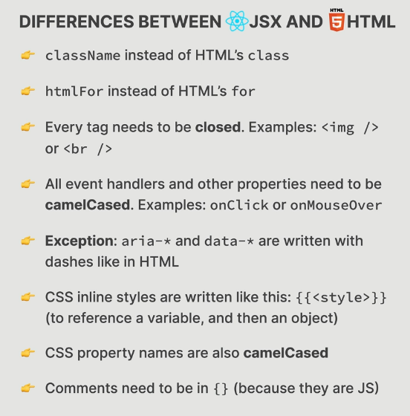
Useful Resources for Part 2

Here are some high-quality resources that you might find helpful while studying this Part 2. (The list follows the order of sections in this part)
These resources are 100% optional, but might give you additional insights or provide ever deeper dives into some topics.
? Writing Resilient Components (By Dan Abramov from the React team)
? Things I think about when I write React code (GitHub repository)
? A (Mostly) Complete Guide to React Rendering Behavior (By Mark Erikson from the redux team)
? A Visual Guide to React Rendering (A multi-part series, check out the other ones)
? Inside Fiber: in-depth overview of the new reconciliation algorithm in React
? A Cartoon Intro to Fiber (YouTube video)
? What Is React Fiber? React.js Deep Dive (YouTube video)
? The React and React Native Event System Explained
? Under the hood of event listeners in React
? A DIY guide to build your own React
? useSyncExternalStore First Look
? Under the hood of React's hooks system
? Why Do React Hooks Rely on Call Order? (By Dan Abramov
? So you think you know everything about React refs
? react-use: Reusable React Hook Library (GitHub repository)
? react-hookz: React hooks done right (GitHub repository)

Section 11 – how react works

Components, instances, and elements

A component can be thought of like a class declaration but it is function based. Therefore a component is 'blueprint' or 'template' that describes a piece of a UI and returns an (react) element. Due to this each time you add a component element to the component tree it is an instance which holds it's own state and props and has it's own life-cycle. When each instance is created with the <ComponentName /> declaration, behind the scenes the JSX that is returned is converted to a jSX element via the React.createElement method and it is this element that is added to the DOM of the app (page) where it is rendered as an HTML style element. (ps a react element has a property called $$typeof which is a javascript primitive type of Symbol() - this is to stop elements being able to be transported from an api as it cannot be converted to json; this is a security feature)

How reandering works...

Rendering is triggered usually due to a change of state, but also for it's initial render, and react goes into it's internal render phase where it calls the component functions (remember how derived variables are reinitialised when state changes which shows this part of the process) and works out what affect the changes will have on the virtual DOM. After this there is a phase called the commit phase which is where react actually rewrites (or 'writes to') the DOM with it's updated view (ie removing elements that are hidden, inserts new elements, changes the content, etc) and it is this phase that triggers the browser paint functionality at at this point the browser view now reflects the internal react view.

The render phase in more detail -

The virtual DOM is essentially just a js object. When the state changes within a component react re-renders that component and also any of it's children. This is why it is preferable to have state in the highest neccessary component, but NOT in the highest component overall (especially when working within very large applications) see below for description slide...

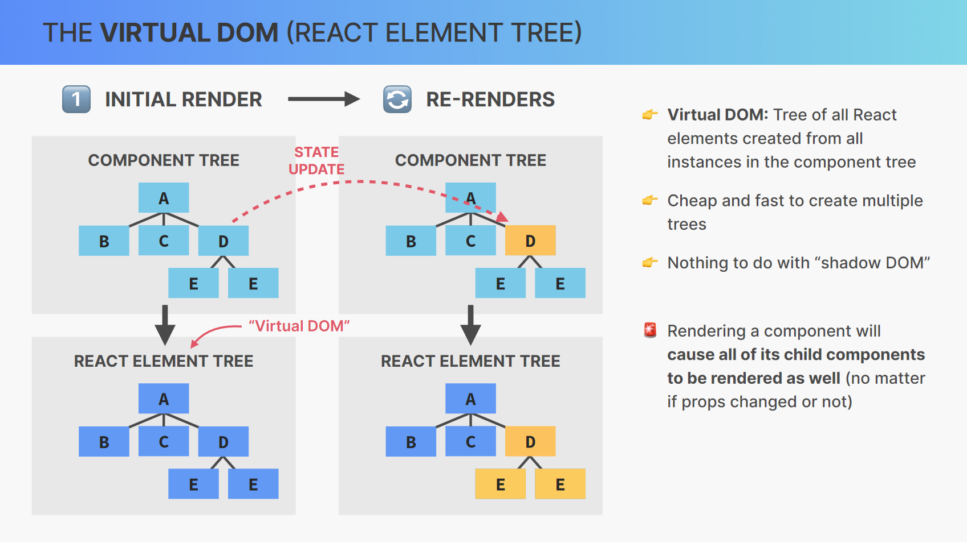
During the initial render the entire DOM is constructed but after that it is inefficient and relatively slow to re-construct the entire DOM and so the 'engine' of react is it's reconciler program called Fiber. This goes through the process of deciding how little needs to be changed to reflect the state of the virtual dom to the DOM itself. This phase is therefore reffered to as updating the fiber tree (which is a mutable linked-list structure and so does not need to be recreated)

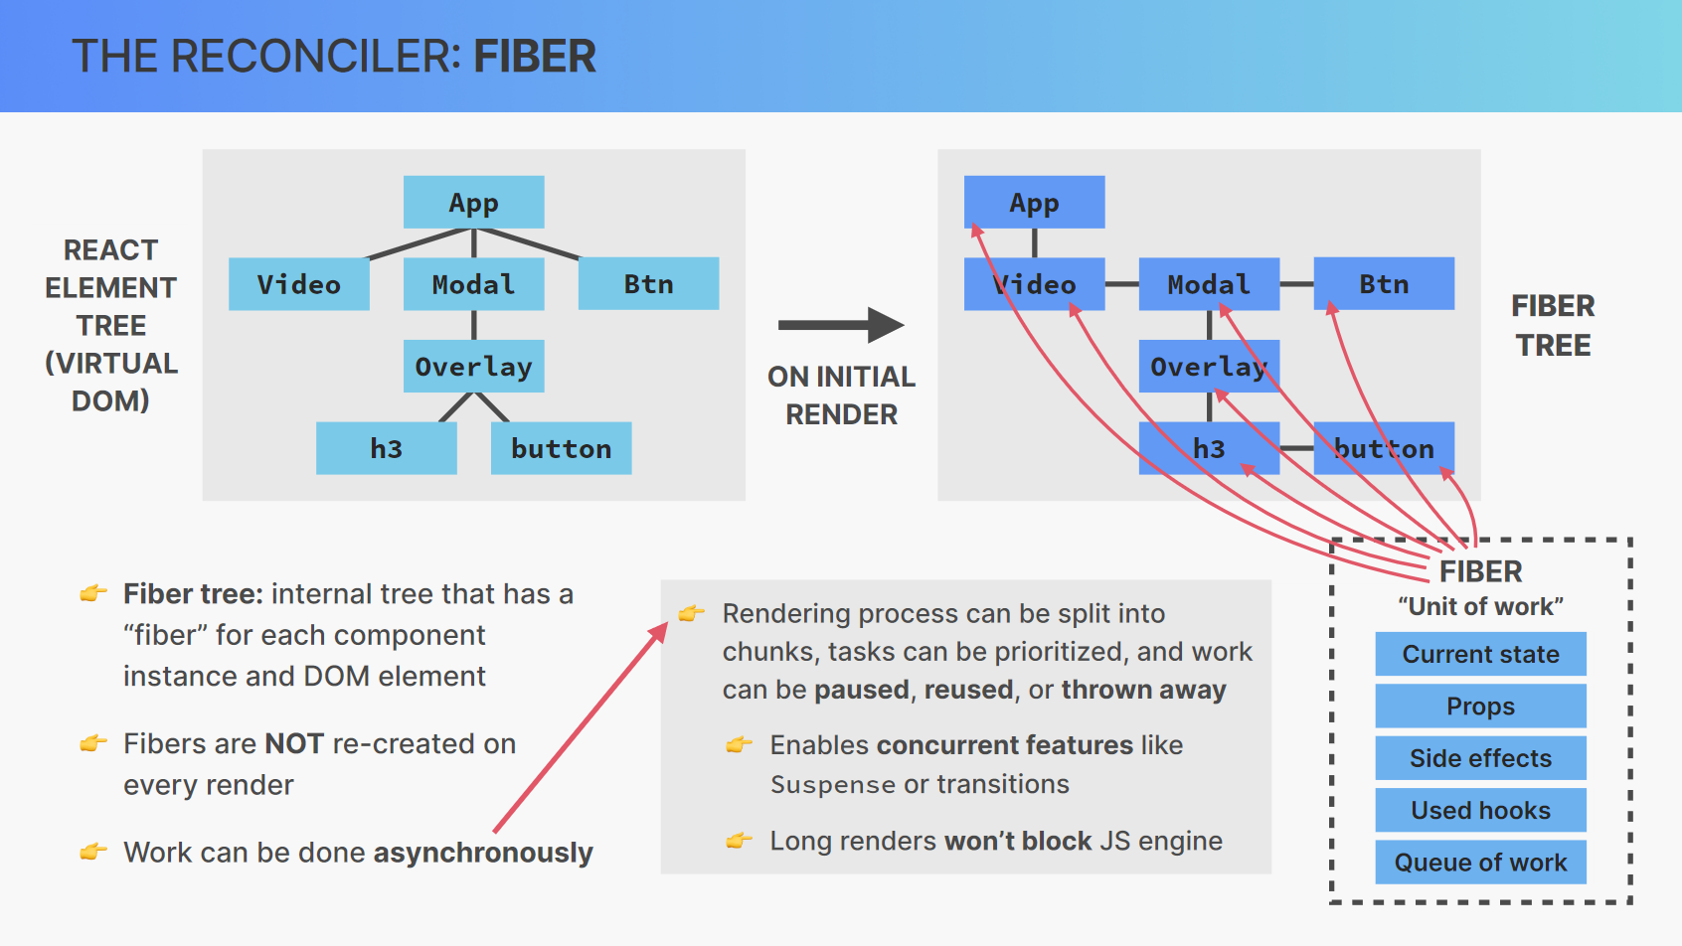

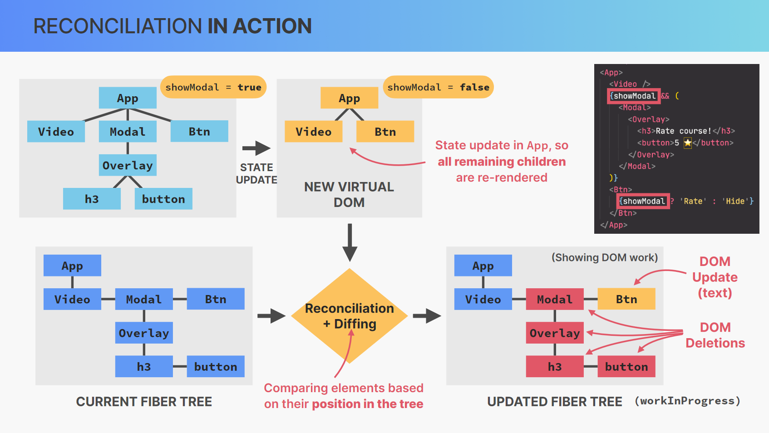
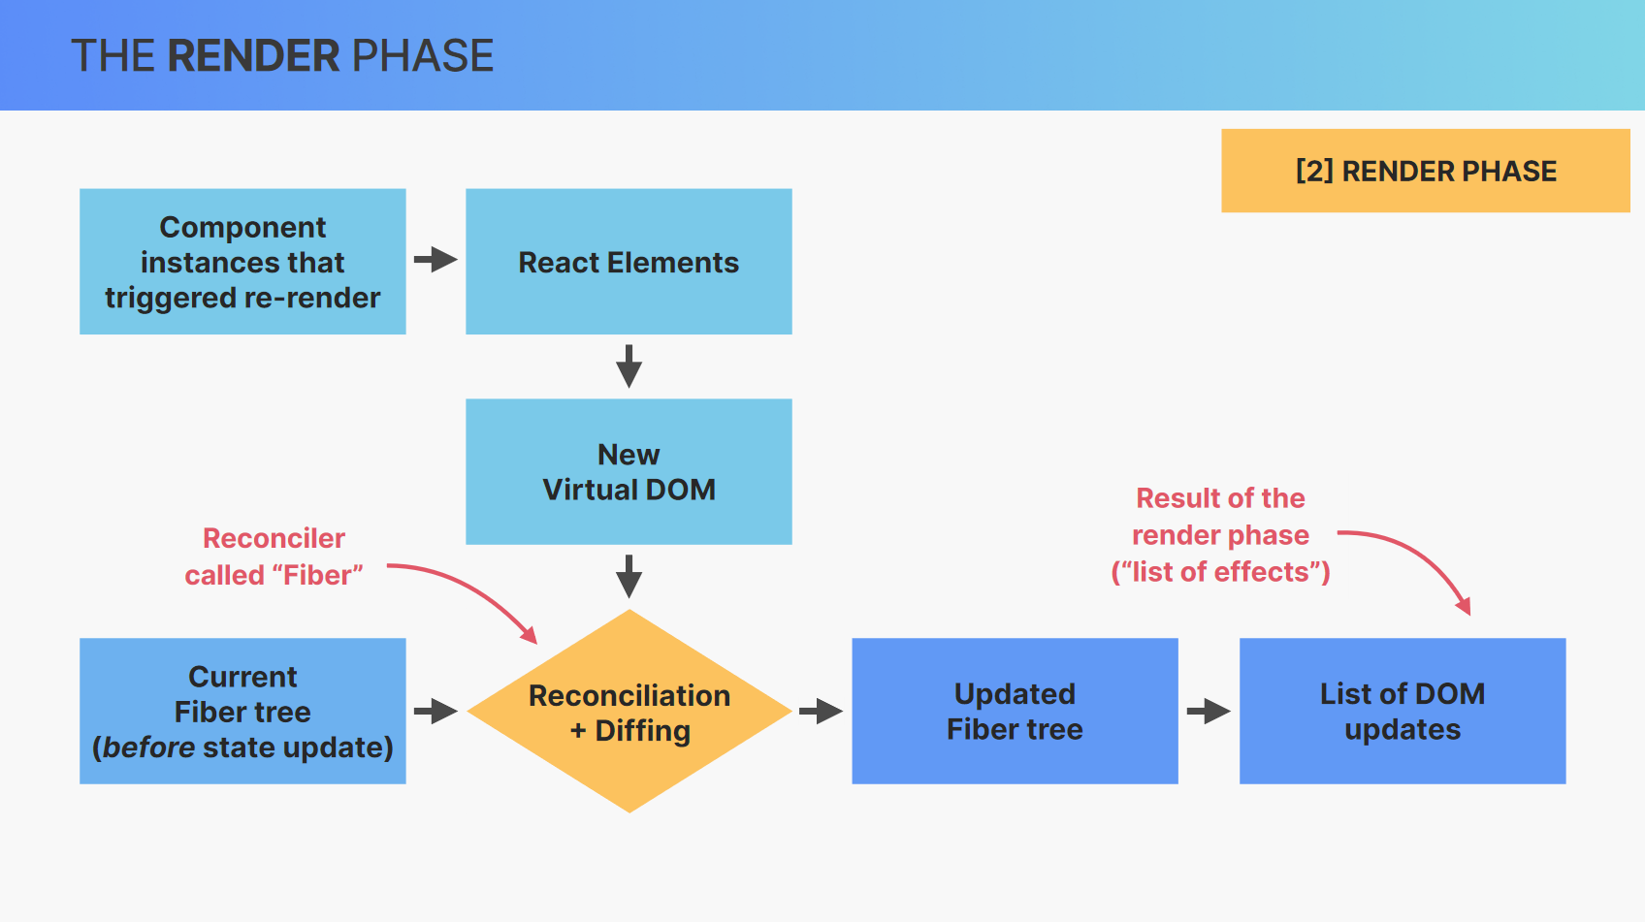
And then into the Commit Phase

The phase where react finally writes (flushes) to the DOM which is a synchronous process (ie it all happens at once) unlike the render phase. This causes the browser paint phase and so the view is updated. At this stage we can use ReactDOM for web pages/apps, or ReactNative for IOS/Android, etc to output to different 'hosts' (platforms)

How diffing works
An algorithm based on the assumptions (1) Two elements of different types will produce different trees, and (2) Elements with a 'stable key prop' stay the same across renders (hence the need for a key prop on any element in a list I guess?)

Important – when a parent component is re-rendered, and all of it's children too, you must keep in mind that all state will be destroyed and therefore 'reset' but this is not true when only a prop changes unless the key prop is changed too.

Principles of functional programing and rules for 'Pure Components'

A pure function has no side effects – a side effect is when a function depends on/modifies any data outside of it's own scope.

A pure function is predictable – given the same input you will always recieve the same output eg function area(r){return Math.PI * r**2;) is completely predictable whereas if we multiplied by time for example then the output would not be predictable

Render logic – this is all of the state and the returned JSX (ie not functions such as handler functions) and this must be pure! This is why we are not allowed to mutate data which is outside of the scope of the component when creating lists of components for example. Consider the component as a pure function but in terms of props relationship with the returned JSX and so a component must always produce the same output if passed the same props. This is why within JSX we cannot -
- perform network requests
- use timers (such as setInterval()
- mutate objects or variables outside of the components scope
- or, update state (or refs) directly
If we need to have render logic have a side effect then we can use the Hook called useEffect which registers the side effect.

State Update Batching

Remember that renders are NOT triggered immediately but instead they are scheduled for when the JavaScript engine has 'free time', and, multiple setState calls within handler functions are in fact 'batched'. We have come across this issue whilst playing with setting one bit of state according to another bit of state which we have set within the same function scope; the new state is not immediately available. This is why we use callback functions within a state setter funcion call if we need the state to be rendered rather than batched with the other state changes within the same function block eg -
const [ans, setAns] = setState('answer')
const reset = function (){
setAns('');
console.log(ans);
} //the output would be "answer"

whereas if we set the state by saying
setAns((ans) => '')
//the output would now be '' (ie the empty string we just set it to

Batching is highly efficient but as shown can have some unexpected side effects. Before React v18 this batching was only done for event handlers but now it works on timeouts, promises, and even native events (ie el.addEventListener()).

If you see a state-setter function wrapped in ReactDOM.flushSync() then that is because the developer wanted to opt out of batching it.

If we call state-setter functions but they do not alter the state then remember that the component will NOT be re-rendered

How events work in react

When an event occurs an Event object is created in the root element, in the browser at the top of the DOM tree, namely within the document object. This event object then passes down through the elements that make up the DOM tree, in a process known as the 'capturing phase', until it gets to the element that caused the event known as the 'target element' (let's say the button which was clicked on). Within this element the Event object is passed through to the optional event handler on that object, after which it is then passed back up the tree in the process known as the 'bubbling phase'.

During the capturing and bubbling phase the event object passes through every child, and every parent, element as if it could have originated in each of them. By default event handlers listen for the event not only on the target element but on all of the other elements it passes through as it bubbles back up. Given this, the event handlers in any parent element that is listening for the same type of event will be executed during the bubbling phase. Keep in mind that 'e.target' value that you can extract in event handlers, well that's this event object as e and the target is just that, the target element (or element that triggered the event to be created).

So as an example if we had a button inside a div which was inside a header and the header also had an onClick event handler, this event handler would also be executed after the button (target) event handler had. To stop this behaviour, namely to stop the event being passed back up the tree, you can use stopPropagation() method on the event object (ie e.stopPropagation()) however this is generally bad practise and rarely neccessary.

Instead, due to this bubbling we can place the event handler within the parent of a group of possible targets which is known as event delegation. This can help with performance and memory usage. In React all events are actually delegated to the root element behind the scenes, within the Fiber Tree discussed above. This means that there is only one event handler for each type of event with a very clever bit of bundling that means all of the child element's handler functions are actually executed from there. Keep in mind that all this event stuff is related to the DOM Tree NOT the Component Tree.

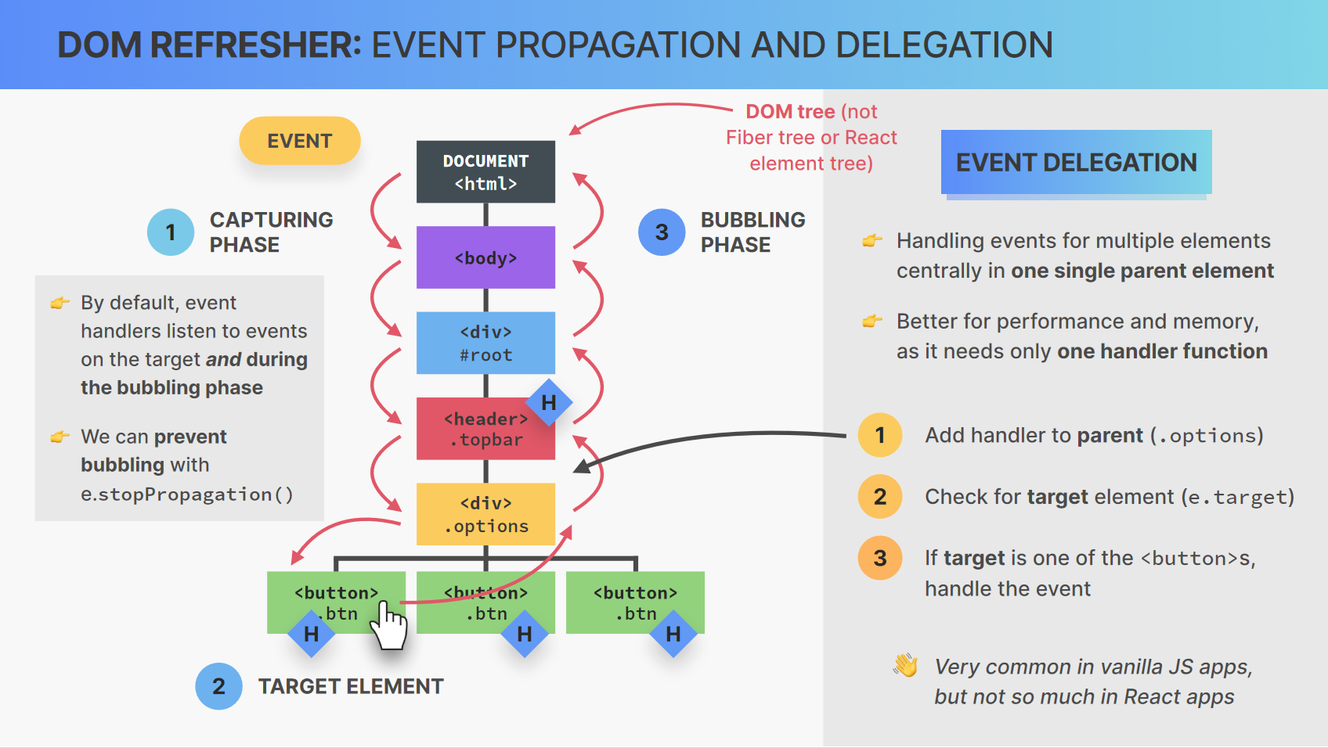
In React the native DOM Events are wrapped in a Synthetic Event class which removes inconsistencies between browser implementations. These have pretty much the same interface as the native objects, however returning false from an event handler will not stop the default behaviour and so you must always use the preventDefault method of the event object that's passed into the handler. The only other major difference is that synthetic events all bubble (except for scroll) unlike their vanilla JS counterparts where there are several that do not (such as blur, focus, and change)

It is because of these synthetic events that our events are named slightly differently so instead of js 'click' (which is also html onclick) we use a camel case version of the html handler name, namely onClick. If for any reason you wish to handle the event during the capture phase (ie when it is passing down from the top of the tree) you can simply add Capture to the end of the name eg onClickCapture.

Libraries vs Frameworks – The React Library and Ecosystem

You can think of a framework as a kit that includes all of the various libraries tied together into a single entity (see Angular, Svelt, or Vue). This is a great way of having everything provided that you might need but you give up the ability to choose different libraries for different parts of the process (ie styling, http requests, routing, etc) and you have to work with the tools and in the style dictated (like OpenFrameworks does)

React on the other hand is considered a javascript library as it is only there to look after the 'view' part of the process and therefore has to be used in conjunction with other libraries to perform the other tasks involved in creating a larger scale application. This gives you the flexibilty to only include the functionality that you require. Other third-party libraries that are often used form the React Ecosystem.
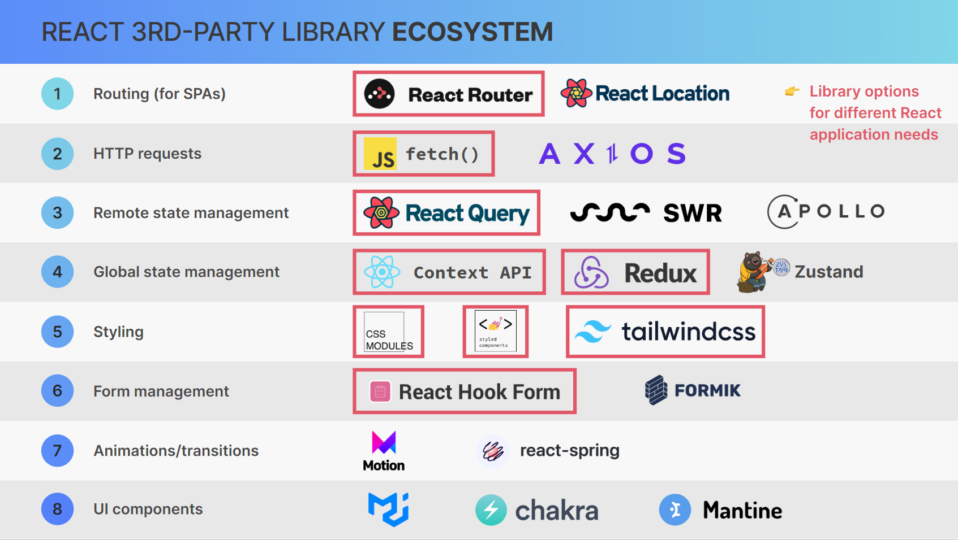
There are several React Frameworks, namely frameworks that have chosen which other libraries to use and include built on top of the React library to produce Full-Stack Frameworks. Some to note are Remix, Next.js, and Gatsby.

Using Effects with useEffect()

Compnent (instance) Lifecycle

Mount/Initial Render – rendered for the first time with fresh state and props
Re-Render – when – state changes, props change, parent re-renders, context changes
Unmount – destroyed/removed and all state and props are destroyed

This is useful to keep in mind when working with effects, along with remembering that 'render logic' (ie anything that is produced when a component is rendered or re-rendered but not event handlers and the such) must be pure and therefore have no side effects. That's where the use of effects comes into play as you might/will want a component to do things when rendered but in a controlled way (eg only on initial render).

As an example we created this bit of code to fill the movies state with an api call response when first loading, it is worth noting that this action is executed after the initial render of the component but I do not think it causes a re-render even though the state has been changed -
useEffect(function () {
fetch(`${OMDbURL}${OMDbKEY}&s=beautiful`)
.then((res) => res.json())
.then((data) => setMovies(data.Search));
}, []);

The useEffect hook is essentially used to keep our components synchronised with external (asynchronous) data; if you can put the 'side effect' into an event handler instead then DO.

UseEffect has 3 parts – the handler function, the clean-up function (which it can return), and it's dependency array (which controls when it should execute) ie
useEffect(function (){.... return () => cleanUp}, [dependency array])

The useEffect function cannot return a Promise and so we cannot make it async, instead we call an seperate async function from within it if we want to work in the tidier way without chains of then() statements eg the same as above would be -
useEffect(function () {
async function setMoviesEffect() {
const res = await fetch(`${OMDbURL}${OMDbKEY}&s=beautiful`);
const data = await res.json();
setMovies(data.Search);
}
setMoviesEffect();
}, []);

A handy little function of the dev-tools in Chrome is that in the network tab you can emulate different connection speeds by setting the 'throttle' as shown here -
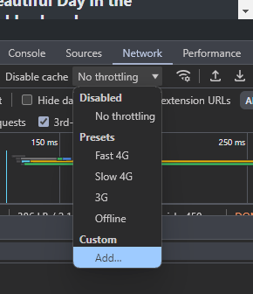
By default effects will run after evry render but this is usually not what we want when we use them; this is why we can pass a dependency array through as the second argument. By passing this array we can control when the effect executes as it will only run when one of the dependencies included changes. This array must include any state variables or props that are used inside the effect. If these variables are not passed in via the dependency array then the effect will not have access to the changed variables when it runs and this will lead to something called a "stale state".

